How to run in Github codespaces

Open Repo
Go to repo https://github.com/jigar3730/finance-vibe
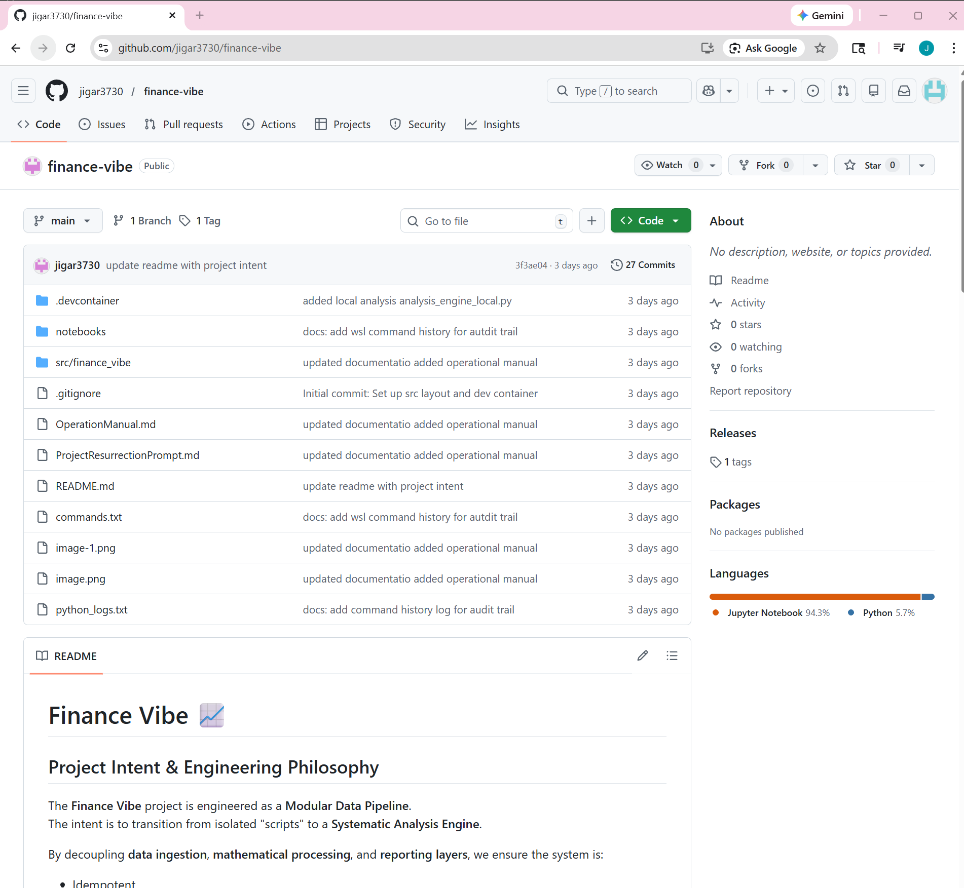

Open the Repo in a Codespace

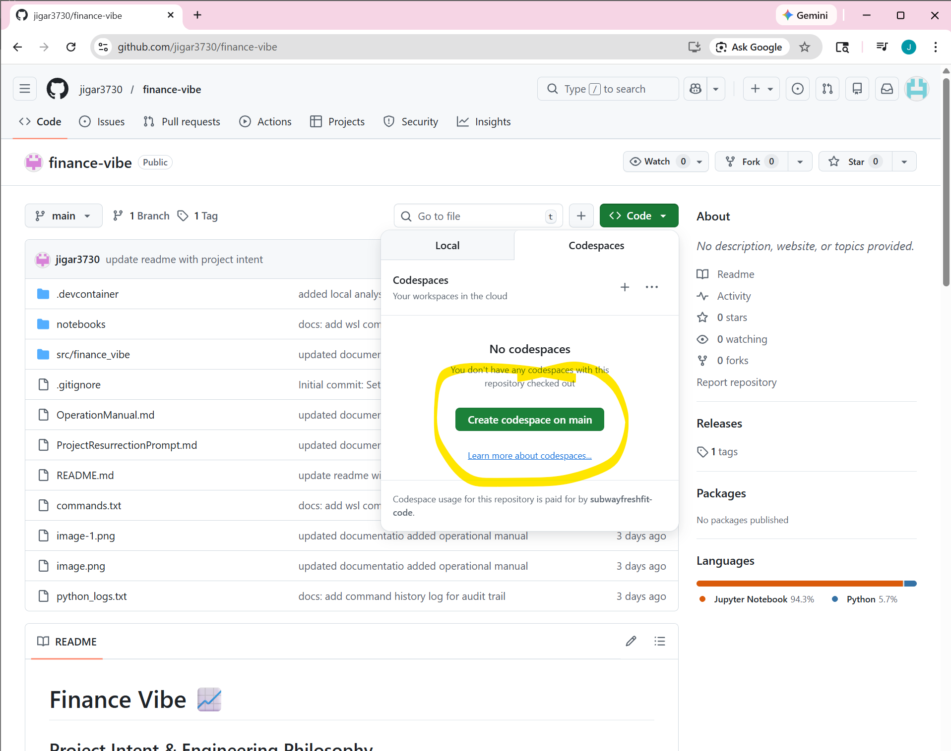

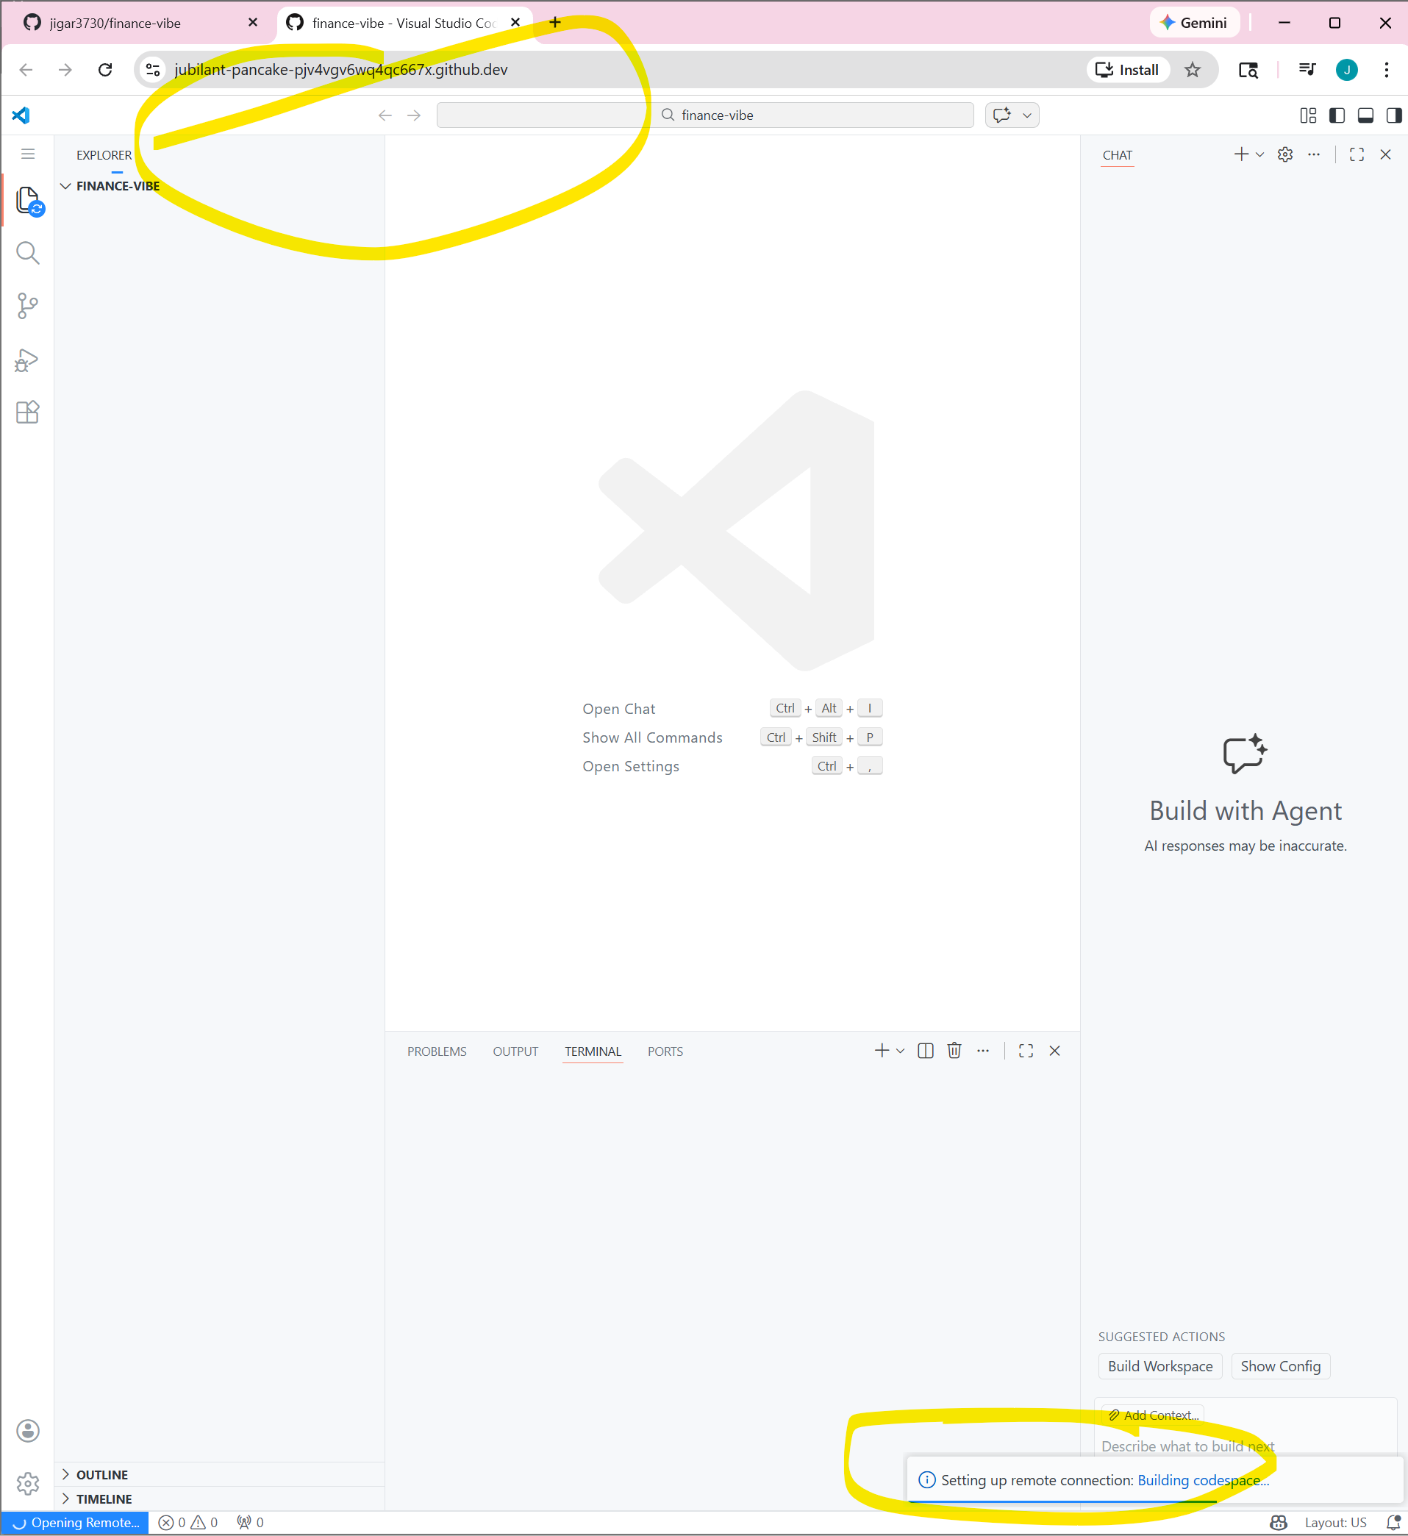

This should open up new window and start building Codespaces terminal

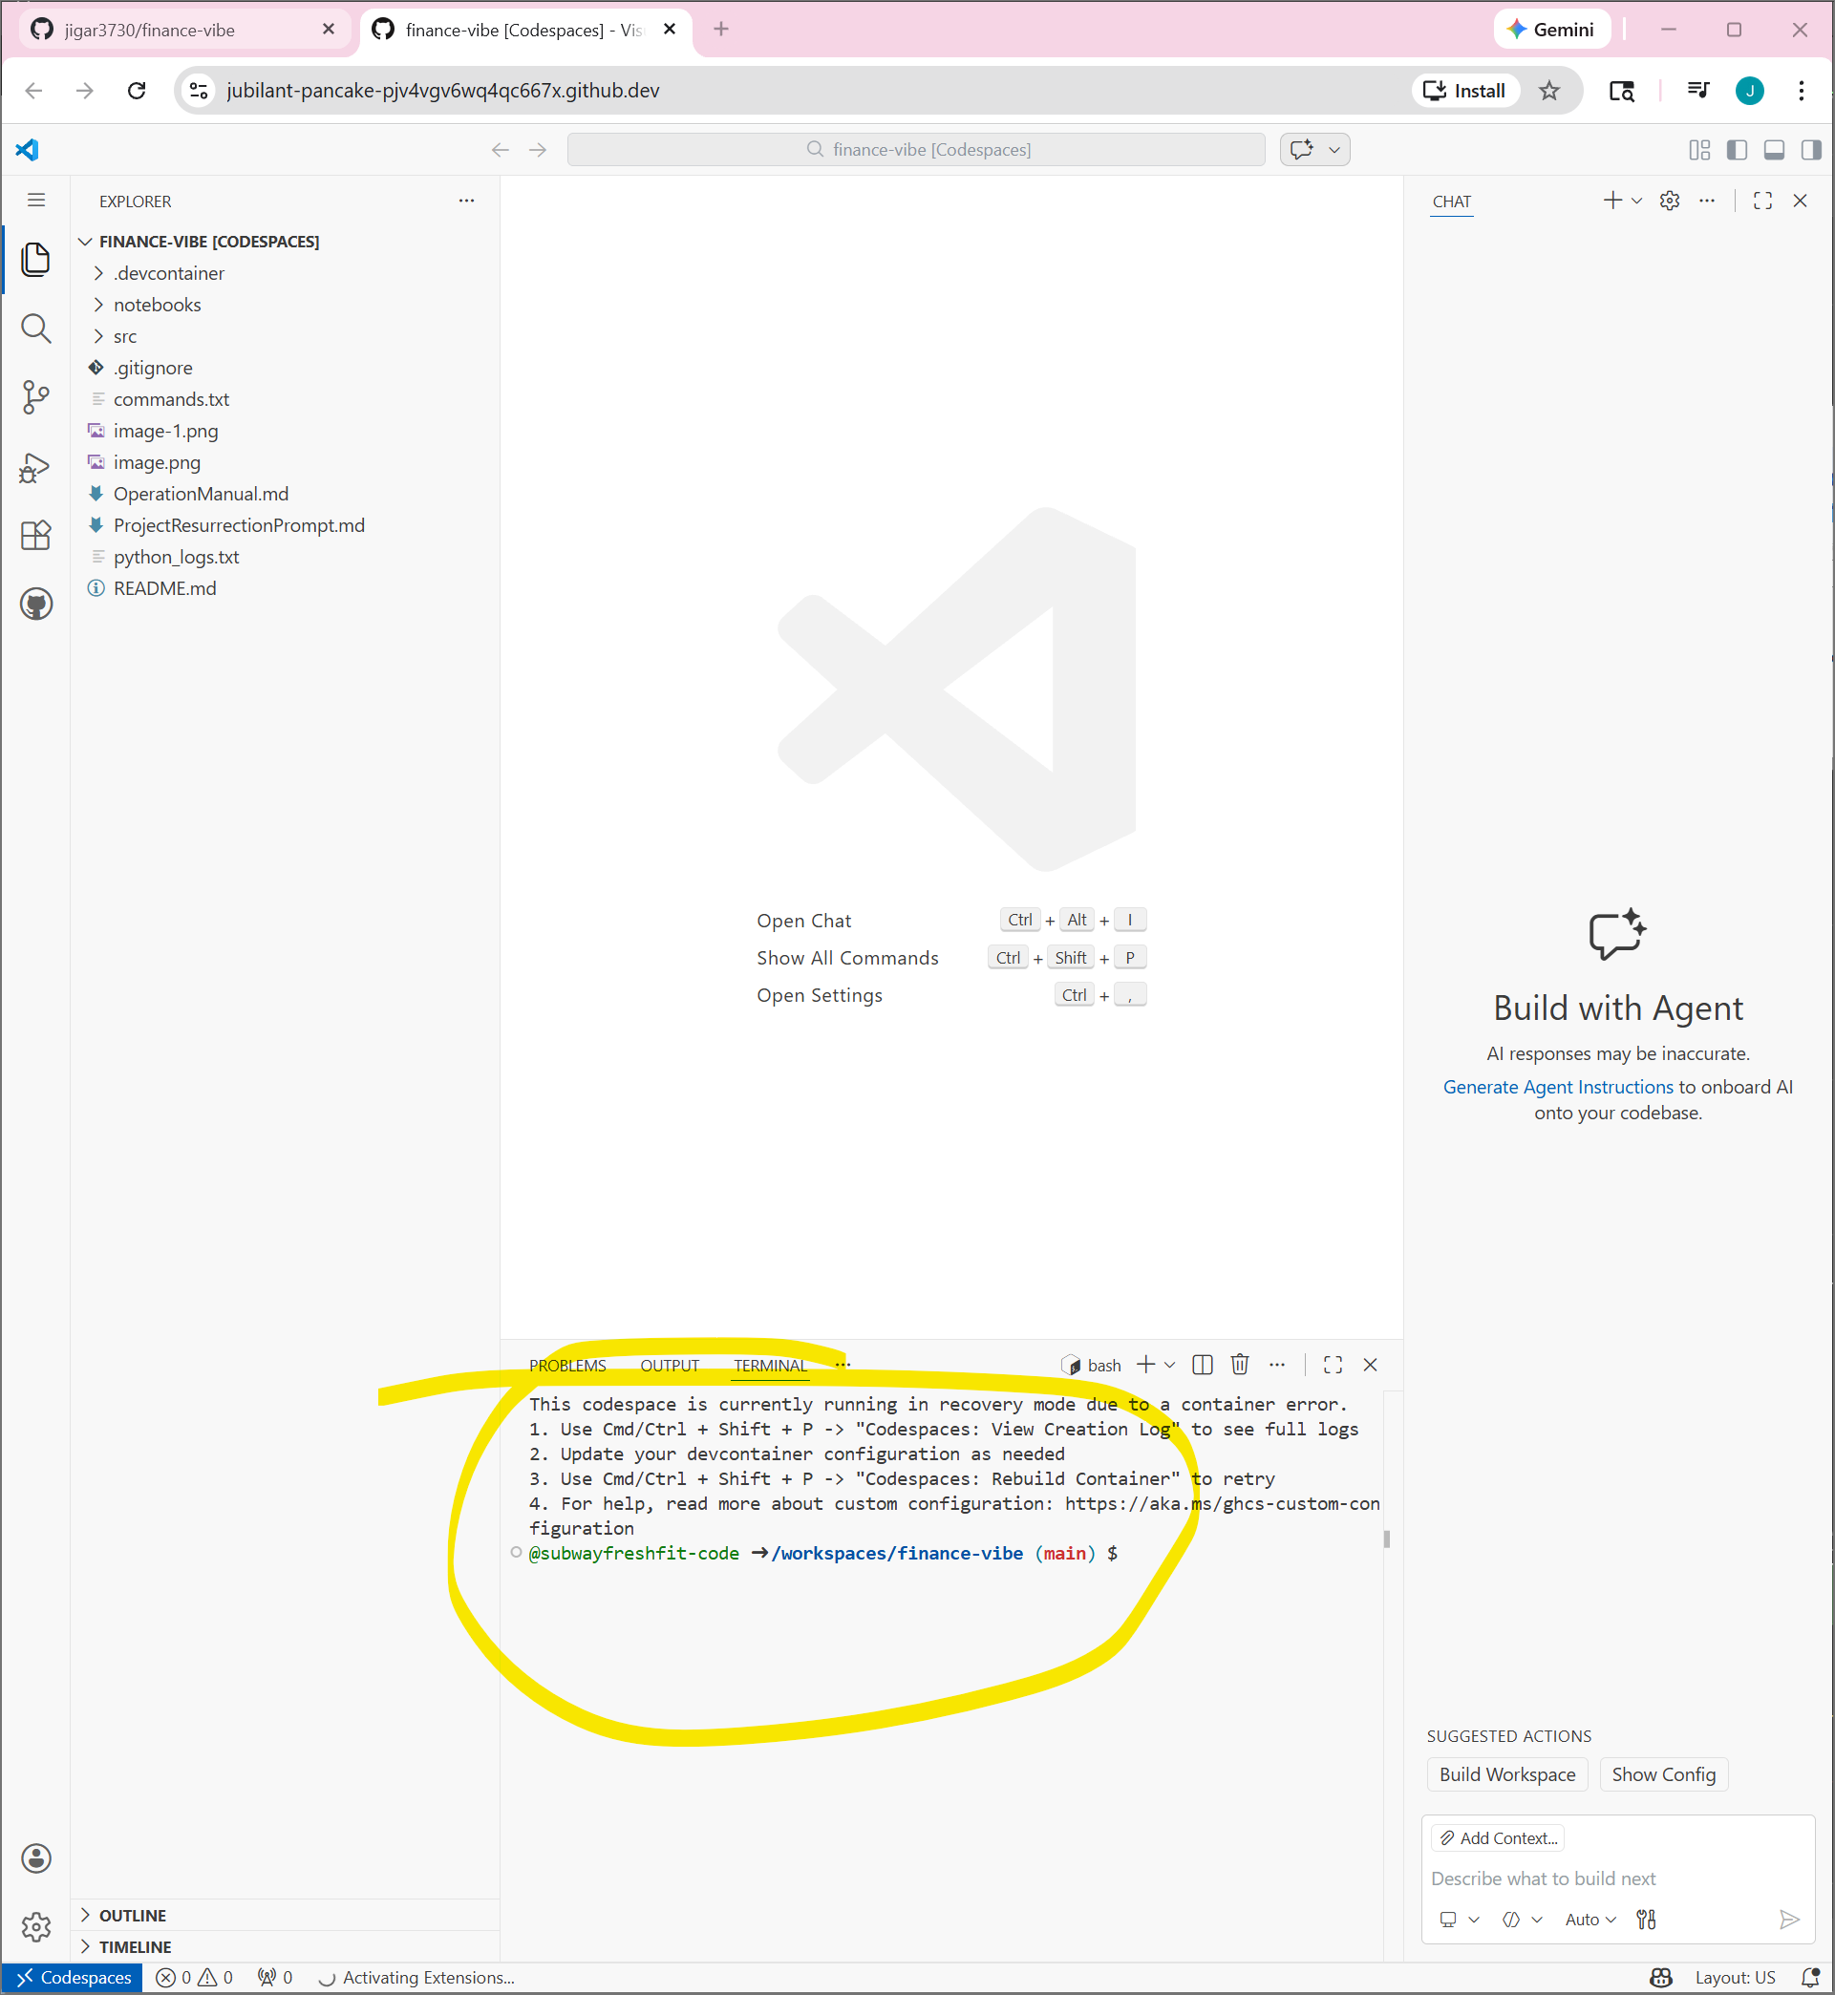

How to fix errors
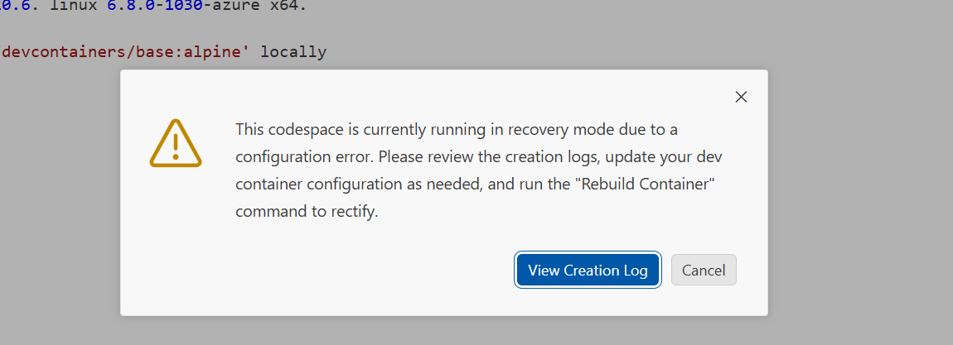
CTRL+ Shift +P
Select “Codespaces: View Creation Log” If there are errors you will see it here
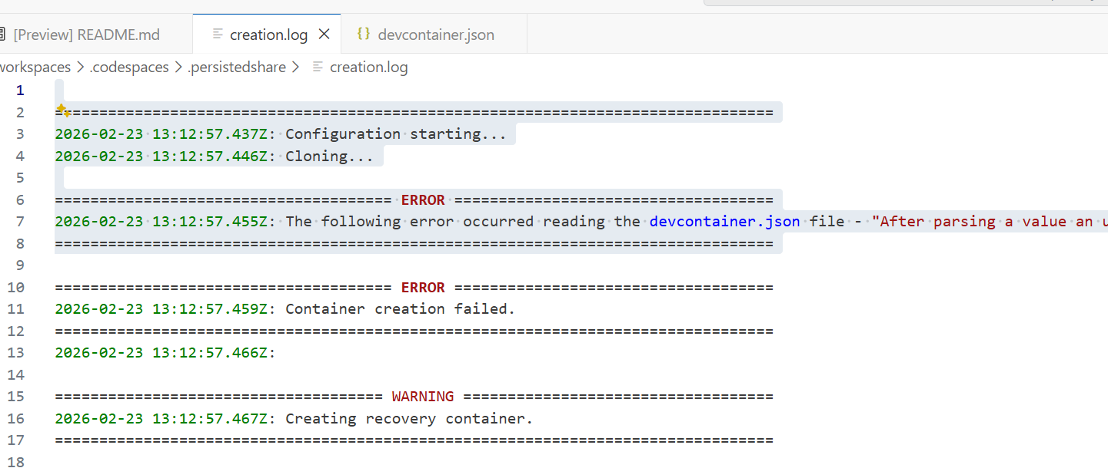

Read the errors
=================================================================================
2026-02-23 13:12:57.437Z: Configuration starting...
2026-02-23 13:12:57.446Z: Cloning...

====================================== ERROR ====================================
2026-02-23 13:12:57.455Z: The following error occurred reading the devcontainer.json file - "After parsing a value an unexpected character was encountered: ". Path 'customizations.vscode.extensions[5]', line 13, position 16." Please see https://docs.github.com/en/enterprise-cloud@latest/codespaces/setting-up-your-project-for-codespaces/introduction-to-dev-containers#devcontainerjson for help configuring your file.
=================================================================================

Fix errors system will prompt you to rebuild post updates to dev container
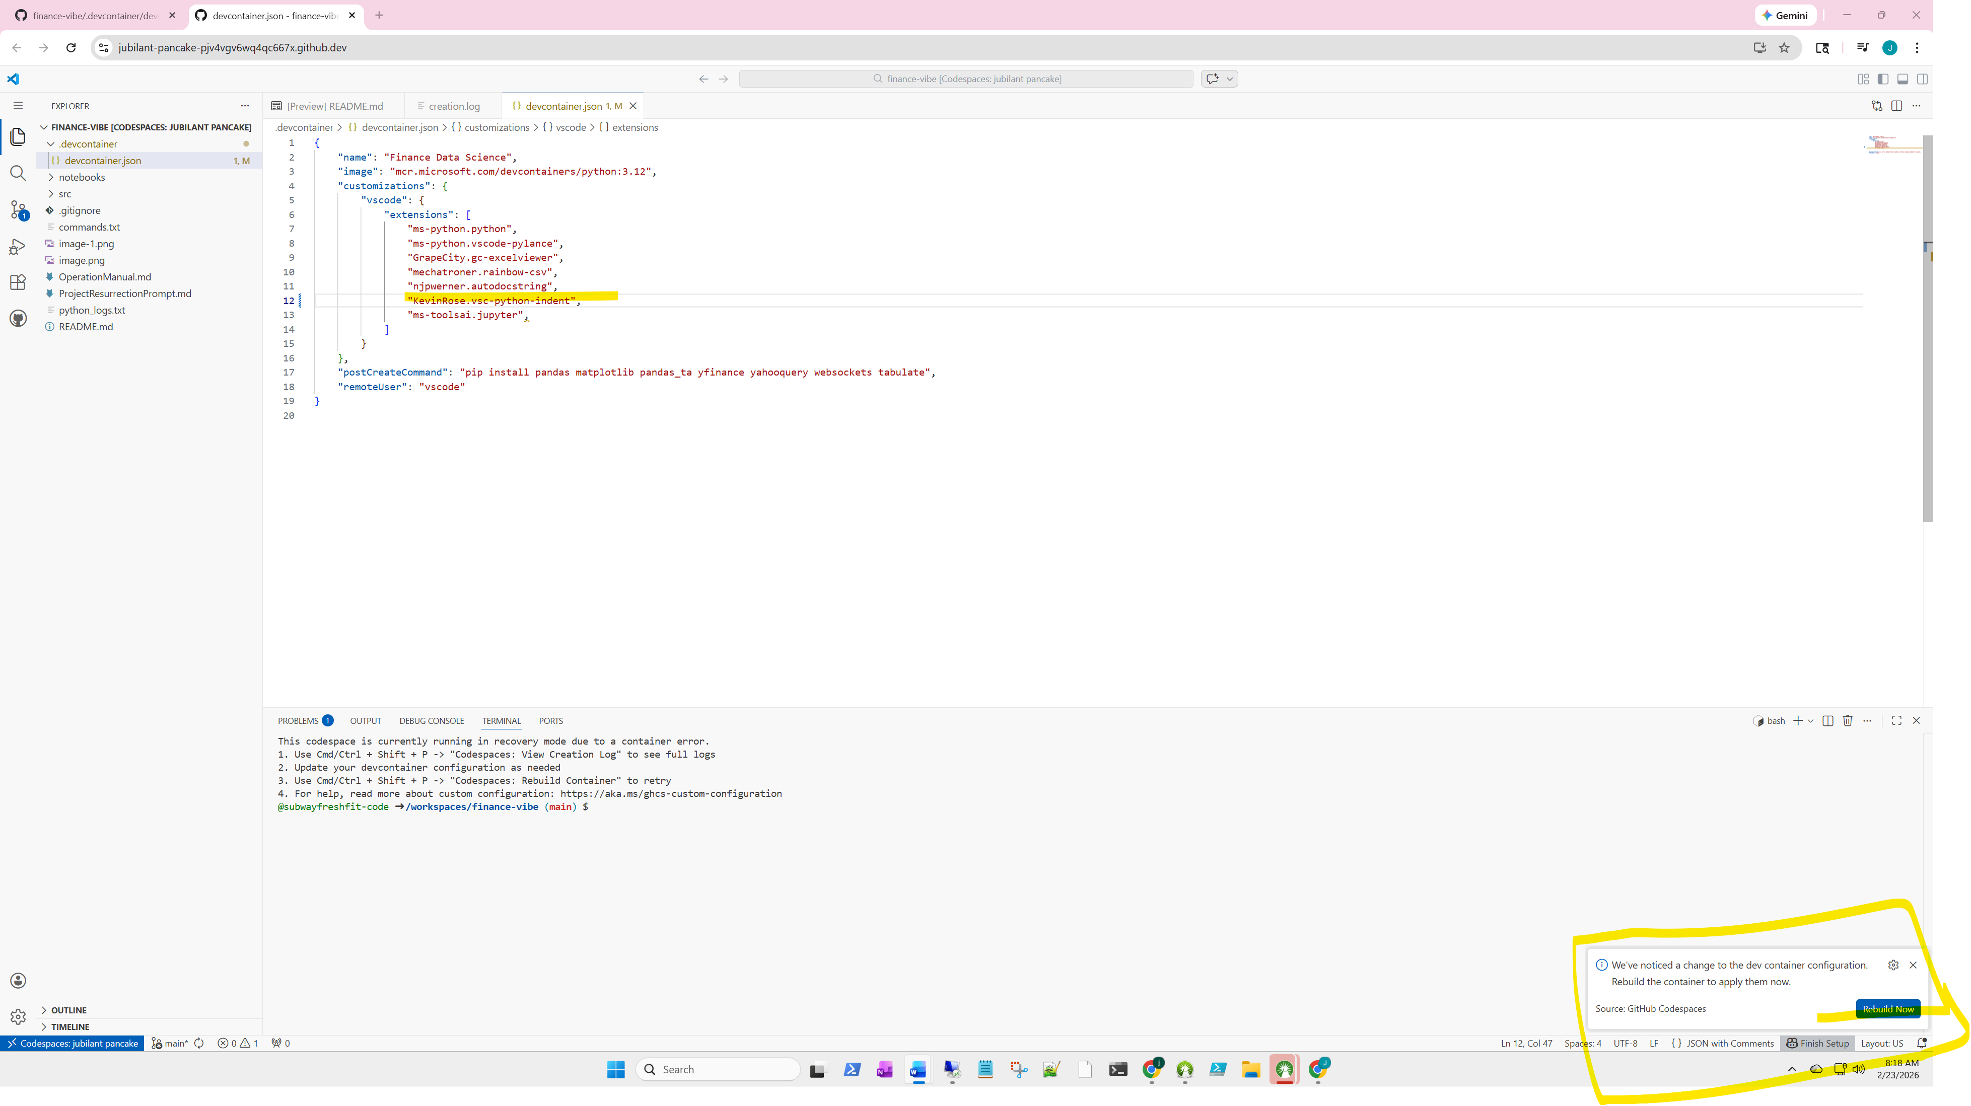
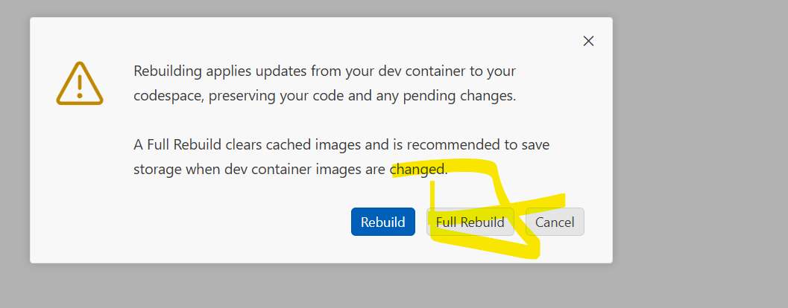

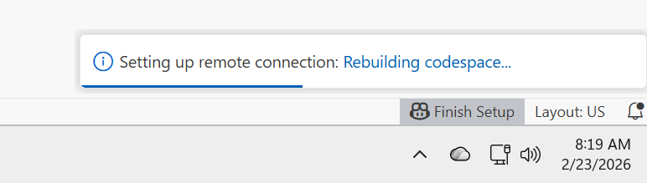

What successful creation looks like
You will see terminal running

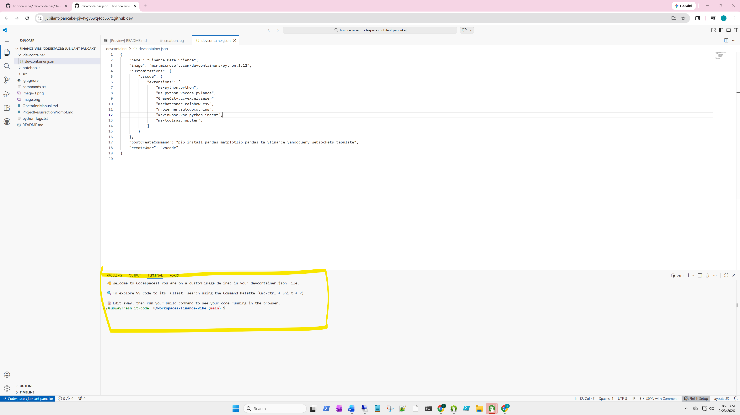

Check if python is there
python –version
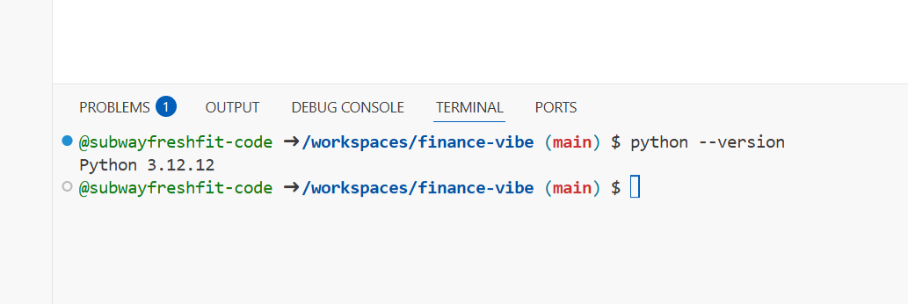

Run script
